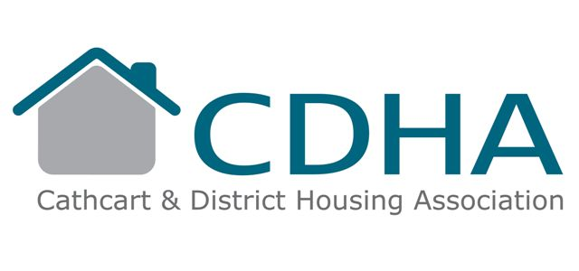
3 Rhannan Road
Cathcart
Glasgow
G44 3AZ
Telephone 0141 633 2779
Fax 0141 637 7088
E-Mail Lorraine@cathcartha.co.uk
Website www.cathcartha.co.uk

Questionnaire for All Owners

We are currently in the process of updating our system and would be obliged if you would complete and return this questionnaire to ensure that all owners understand our role as Factor (detailed on the attached Statement of Factoring Services) and are receiving the services they wish.
This questionnaire can also be completed through our website www.cathcartha.co.uk

Name/s ______________________

Address _________________________________________________

Are you aware that CDHA are your Factor Yes/No (delete as appropriate)

Are you happy for CDHA to continue to Factor your property Yes/No

Are you happy with the services we provide Yes/No

Do you wish to add any services ie Garden Maintenance/Backcourt Cleaning Yes/No
(Please note that we cannot add or remove any of the services currently in place without the agreement of the majority of owners)

Are you a Private Landlord Yes/No

If you are a landlord please supply a correspondence address _________________________________________________

_________________________________________________

Date of birth (optional) ________________

Daytime contact number ____________________

Evening contact number ____________________

National Insurance number (optional) ________________

