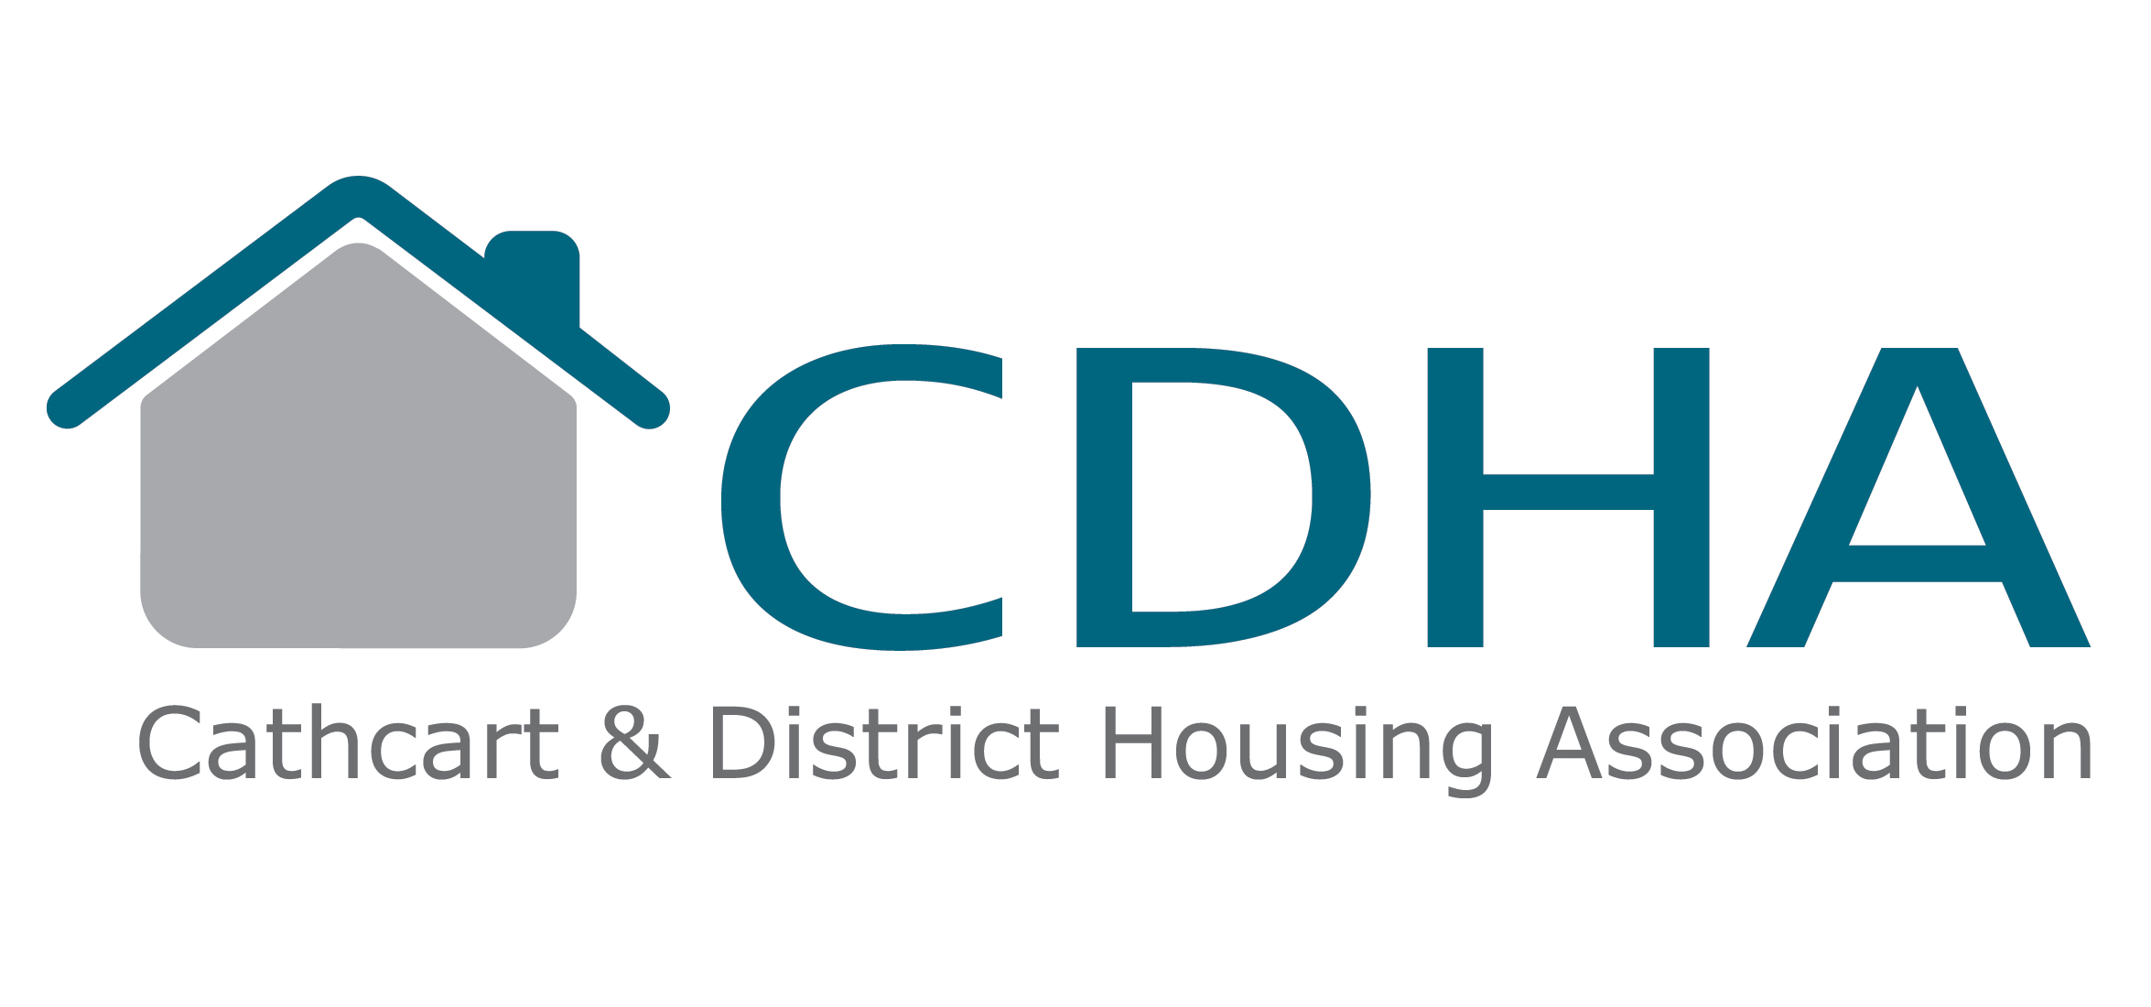

ARREARS
WHAT IS YOUR RENT?

When you signed your tenancy agreement with Cathcart & District Housing Association you entered into a legal agreement. This means that you have various rights and responsibilities.

One of these responsibilities is to pay your rent and service charges (if there are any)

If you do not pay your rent, your rent account goes into arrears and you have broken an important part of your tenancy agreement. As a last resort Cathcart HA can take action to end your tenancy.

This leaflet sets out the various stages we will go through to collect rent that is not paid on time.
Stage 1: Initial contact

We keep electronic records on our computer system of all payments received.

If you don’t pay your rent we will send you a letter reminding you of the debt and requesting that you make a payment or contact us to discuss the arrears.

We do this because we want to help you if you are having difficulties. It is far easier to sort out problems if the amount involved is a small one.

If the amount is paid or you make an arrangement with us to pay in instalments, we will take no further action.

IF YOU ARE HAVING DIFFICULTY PAYING YOUR RENT YOU SHOULD CONTACT YOUR HOUSING OFFICER AS SOON AS POSSIBLE
Stage 2: Second contact

If we don’t hear from you one week after sending the initial letter, or if you fail to keep to the repayment plan, we will send a second letter stating that we may consider starting a legal process if we do not hear from you.

The second letter will be a final warning letter and you must at this stage make contact with the Association to protect your home.
If you contact us and bring your payments up to date or arrange a payment plan the arrears recovery procedures will stop.
Stage 3: Home Visit

If there is still a problem after our second contact we will send you a letter advising that we are going to come and visit you to discuss your arrears. We want to give you every chance to contact us or pay off your arrears.

At this visit we will discuss your arrears and financial circumstances. You will be able to let us know if you are having difficulty paying your rent and if this is what has led to your account going into arrears. We will try and give practical advice and put you in contact with a money advice officer if necessary.

At this point you can still stop the arrears recovery procedures by either bringing the account up to date or arranging an instalment plan with us.

If we still do not hear from you or fail to gain access at the appointed time we WILL commence legal proceedings.

Stage 4: Legal Action

If you were not at home when we visited or you have not contacted us we will have no choice but to issue a Notice of Proceedings for Recovery of Possession (NOP) This is a formal document starting the legal proceedings to recover the debt and in many cases the property.

If you receive this document you will have 28 days to contact us to make full payment to stop the proceedings. If we do not hear from you we will instruct our solicitor to start court action to recover the debt or property.

COURT ACTION COULD RESULT IN YOU BEING EVICTED FROM YOUR HOME
Eviction

If you are evicted from your home due to not paying your rent and building up arrears, this will have serious implications on any housing applications you make afterwards.

Depending on circumstances, Local Authorities and other Registered Social Landlords may not have any legal obligation to find you permanent accommodation.
Further Advice

If you find yourself in financial difficulty or threatened with eviction, it is very important to get advice as quickly as possible. Contact your Housing Officer about your arrears or one of many debt advice agencies. For example your local Citizens Advice Bureau (CAB) Your local office can be found on the CAB website.

www.cas.org.uk

