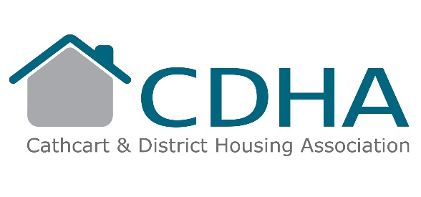
RETURN SHEET

Consultation Questions

Do you think it is important for the Association to have funds
in place to meet all our repair and improvement targets? Yes/No
Do you agree Cathcart is a good place to live? Yes/No

Do you agree that being allocated a property in Cathcart
provides a better life balance than other areas in Glasgow? Yes/No

Do you believe CDHA continues to invest in our properties? Yes/No

Are you aware of the Government requirement to address?
climate change and net carbon zero by 2045? Yes/No

Do you think it is a reasonable aim to be at least on a
par with the national average for rental charges in Cathcart? Yes/No

Do you think we have set our proposals (5.5% increase)
at a reasonable level? Yes/No

Would you like to add any comments?

Name and address (optional) ……………………………………………………………………..

…………………………………………………………………………………………………………

Please return this form to: Cathcart & District Housing Association, 3-5 Rhannan Road, Glasgow, G44 3AZ by 12 noon on Monday 12th January 2026.

